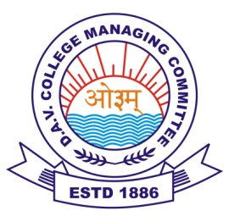
DAV PUBLIC SCHOOL
(Garoru)Tehsil, Joginder Nagar, Distt. Mandi (HP)
Contact No: 9816057965, Pin Code: 175015
ACADEMIC YEAR-2023-24

NAME: - AANVI CLASS: - VII ROLL NO: 2
FATHER’S NAME:- SH VIKASH Mother’s Name:- MRS ANU DEVI
Term-1(2023-24)

SR.NO | SUBJECT | MARKS OBTAINED | TOTAL MARKS
1 | ENGLISH | 20 | 50
2 | HINDI | 30 | 50
3 | MATH | 17 | 50
4 | SCIENCE | 30 | 50
5 | SOCIAL SCIENCE | 32 | 50
6 | SANSKRIT | 32 | 50
7 | M.SC/G.K | 22/12 | 30/20
8 | COMPUTER | 24 | 50

^{TOTAL MARKS:- 219} ^{PRINCIPAL:-}
^{CLASS IN-CHARGE:-} Mr.MOHIT PRINCIPAL:-Mr.SANJAY THAKUR

